ARCHITECTURE:

Project Design Phase-II Technology Stack (Architecture & Stack)

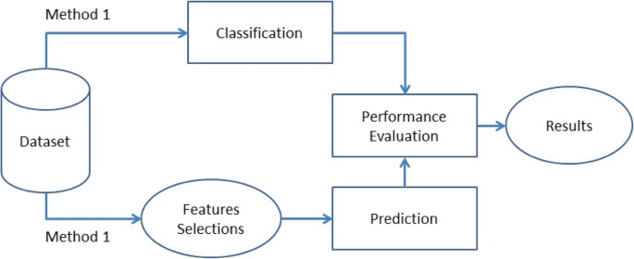

Table-1 : Components & Technologies:

|  |  |  |  |
| --- | --- | --- | --- |
| **S.No** | **Component** | **Description** | **Technology** |
| 1. | Importing data | Data Import lets you upload data from external sources and combine it with data you collect via  Analytics | Python,numpy,pandas. |
| 2. | Data Cleaning | Data cleaning is a process by which inaccurate,  poorly formatted, or otherwise messy data is organized and corrected | Python |
| 3. | Data Preprocessing | Data preprocessing, a component of data preparation, describes any type of processing performed on raw data to prepare it for another data  processing procedure | Python |
| 4. | Training data | Training data is the subset of original data that is  used to train the machine learning model, | python |
| 5. | Testing data | Test data is data which has been specifically identified for use in tests, typically of a computer  program**.** | python. |
| 6. | Machine learning model | A machine learning model is a file that has been trained to recognize certain types of patterns. You train a model over a set of data, providing it an algorithm that it can use to reason over and learn  from those data | python. |
| 7. | Improve model performance | Accuracy is one metric for evaluating classification  models. Informally, accuracy is the fraction of predictions our model got right. | python. |
| 8. | Cheking accuracy | A data accuracy check, sometimes called a data sanity check, is a set of quality validations that take  place before using data. | python. |

Table-2: Application Characteristics:

|  |  |  |  |
| --- | --- | --- | --- |
| **S.No** | **Characteristics** | **Description** | **Technology** |
| 1. | Collection of data | Data collection is the process of gathering, measuring, and analyzing accurate data from a variety of relevant sources to find answers to research problems, answer questions, evaluate  outcomes, and forecast trends and probabilities | Python,numpy,pandas |
| 2. | EDA Analysis | Exploratory Data Analysis (EDA) is an approach to analyze the data using visual techniques. It is used to discover trends, patterns, or to check  assumptions with the help of statistical summary and graphical representations | Technology used |
| 3. | Train & Test split of data | The train-test split is used to estimate the performance of machine learning algorithms that are applicable for prediction-based Algorithms/Applications. This method is a fast and easy procedure to perform such that we can compare our own machine learning model results  to machine results. | Technology used |
| 4. | Model prediction | Predictive modeling is a commonly used statistical  technique to predict future behavior. | Technology used |